Peer Evaluation for Mexican Train Dominos – Review of Chapters 12 - 13
Your name: (Your lab is the one being evaluated)
Name(s) of peer evaluator(s)
Date:

Instructions
You should have already completed the implementation and testing of the Domino, BoneYard and Train classes. After you and a peer have evaluated your work, you will submit this evaluation along with screen shots and source code indicated in moodle.
Mexican Train Domino Problem
Create a solution that included multiple projects? (class library, class library for testing?) Added a using using statement in the tests to access the class library? Added a reference in the test project to access the class library? | y

Classes
Completed Domino Class?  - NO NEED TO INCLUDE SOURCE CODE FOR CLASS OR TESTS.  Completed BoneYard Class?  - Included a class for test fixture? Class is annotated appropriately?  - Included one test for each constructor / property / method? Test is appropriately annotated? Test uses assertions appropriately? Test checks the functionality of JUST ONE THING?  - NO NEED TO INCLUDE SOURCE CODE FOR CLASS. Source code for test fixture is included?  Completed (Public) Train Class?  - Created a class diagram in visual studio? Screen shot included?  - Instance variables are camelCase and private?  - Property/Method names are TitleCase? Properties/Methods are public?  - Implements an appropriate set of properties/methods?  - Source code for class is included?  - Included a class for test fixture? Class is annotated appropriately?  - Included one test for each constructor / property / method? Test is appropriately annotated? Test uses assertions appropriately? Test checks the functionality of JUST ONE THING?  - Source code for test fixture is included? | y

Programming style for all programs
Is proper indentation used? Is each event handler indented properly? Is each method indented properly? | y
Are comments used appropriately? | y
Do variable names use camel case? (camelCase for example) | y
Do property/method names use Title Case (or Pascal Case?) | y

General comments and notes:
Screen Shots and Source Code
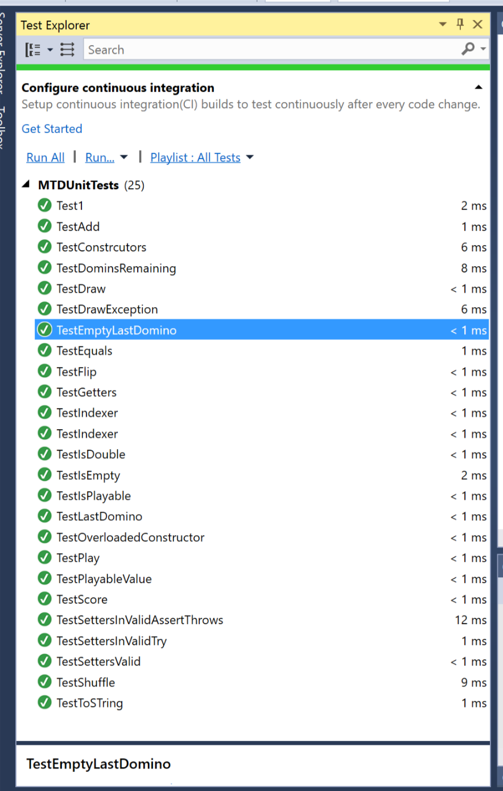

TRAIN CLASS ------------------------------------------------------------------------------------------------

using System;
using System.Collections.Generic;
using System.Linq;
using System.Text;
using System.Threading.Tasks;

namespace MTDClasses
{
public class Train
{
private List<Domino> dominos = new List<Domino>();
private int engineValue;

public Train()
{
engineValue = 6;
}

public Train(int engineVal)
{
engineValue = engineVal;
}

#region properties

public int EngineValue
{
get { return engineValue; }
set { engineValue = value; }
}

public bool IsEmpty
{
get
{
if (dominos.Count < 1) return true;
else return false;
}
}

public Domino LastDomino
{

get { if (dominos.Count == 0)
{
Domino d1 = new Domino(EngineValue, EngineValue);
return d1;
}
else return dominos[dominos.Count - 1]; }
}

public int PlayableValue
{
//assuming side2 of the last dominos is the one on the open end of the train
get { if (IsEmpty) return EngineValue;
else return LastDomino.Side2; }
}

public Domino this[int i]
{
get { return dominos[i]; }
}

#endregion

public void Add(Domino d)
{
dominos.Add(d);
}

public bool IsPlayable(Domino d, out bool mustFlip)
{
//I'm assuming that side 2 is the end right side and side 1 is left and that we're moving right so side 1 of played domino connects to side 2 of dominos on train
if (LastDomino.Side2 == d.Side1) { mustFlip = false; return true; }
else if (LastDomino.Side2 == d.Side2) { mustFlip = true; return true; }
else { mustFlip = false; return false; }
}

public void Play(Domino d)
{
bool flip;
if (IsPlayable(d, out flip))
{
if (flip) d.Flip();
Add(d);
}
}

public string Show(int number)
{
//i have no idea what this is supposed to do
return "noidea_string";
}

public override string ToString()
{
string r = "";
foreach(Domino d in dominos)
{
r += d + "/n";

}
return r;
}

}
}

TRAIN TESTS ------------------------------------------------------------------------------------------------------------------

using System;
using System.Collections.Generic;
using System.Linq;
using System.Text;
using System.Threading.Tasks;

using NUnit.Framework;
using MTDClasses;

namespace MTDUnitTests
{
[TestFixture]
class TrainTests
{

Train t1 = new Train(6);
Train t2 = new Train(6);
Train t3 = new Train(6);
Train t4 = new Train(6);

Domino d61 = new Domino(6, 1);
Domino d13 = new Domino(1, 3);
Domino d53 = new Domino(5, 3);

[SetUp]
public void TestSetup()
{
t4.Play(d61);

}

[Test]
public void TestIsEmpty()
{
Assert.AreEqual(true, t1.IsEmpty);
}

[Test]
public void TestEmptyLastDomino()
{
Assert.AreEqual("Side 1: 6 Side 2: 6", t1.LastDomino.ToString());

}

[Test]
public void TestPlayableValue()
{
Assert.AreEqual(6, t1.PlayableValue);
}

[Test]
public void TestIsPlayable()
{
bool flip;
//should be playable and not need to be flipped
Assert.AreEqual(true, t1.IsPlayable(d61, out flip));
Assert.IsFalse(flip);
}

[Test]
public void TestPlay()
{
t2.Play(d61);
Assert.AreEqual(1, t2.PlayableValue);
}

[Test]
public void TestAdd()
{
t3.Add(d61);
Assert.AreEqual(1, t3.PlayableValue);
}

[Test]
public void TestLastDomino()
{
Assert.AreEqual("Side 1: 1 Side 2: 6", t4.LastDomino.ToString());
}

[Test]
public void TestIndexer()
{
Assert.AreEqual("Side 1: 6 Side 2: 1", t4[0].ToString());
}

public void TestGetEnginveValue()
{
Assert.AreEqual(6, t1.EngineValue);
}

public void TestSetEnginveValue()
{
t4.EngineValue = 2;
Assert.AreEqual(2, t4.EngineValue);
}
//GETS FOR ALL
//EngineValue + SET

}
}

BONEYARD TESTS ---------------------------------------------------------------------------------------------------------------

using System;
using System.Collections.Generic;
using System.Linq;
using System.Text;
using System.Threading.Tasks;

using MTDClasses;
using NUnit.Framework;

namespace MTDUnitTests
{
[TestFixture]
class BoneYardTests
{

BoneYard b1 = new BoneYard(6);
BoneYard b2 = new BoneYard(0);

[Test]
public void TestConstrcutors()
{
Assert.IsFalse(b1.IsEmpty());
}

[Test]
public void TestDominsRemaining()
{
Assert.AreEqual(28, b1.DominosRemaining);
}

[Test]
public void TestIndexer()
{
Assert.AreEqual(0, b1[0].Side1);
}

[Test]
public void TestShuffle()
{
b1.Shuffle();
//it is randomized so may return true on occasion!!
Assert.AreNotEqual(0, b1[0].Side1);

}

[Test]
public void TestDraw()
{
b1.Draw();
Assert.AreEqual(27, b1.DominosRemaining);
}

[Test]
public void TestDrawException()
{
BoneYard by = new BoneYard(2);
try
{
int max = by.DominosRemaining + 10;
for (int i = 1; i < max; i++)
{
by.Draw();
}
Assert.Fail("No Draw Exception");
}
catch
{
Assert.Pass();
}
}

[Test]
public void TestToSTring()
{
//I wasn't sure what to expect with tostring output so just put it in a pass message that can be checked in text explorer
Assert.AreEqual("Side 1: 0 Side 2: 0\n", b2.ToString());
}
}
}

